

**Name: Muhammad Mubbashir Khan**

**Sec: B**

**Lab manual: 6**

**CMS: 465077**

**Task no: 1**

#include <iostream>

using namespace std;

int main(){

int n,i,b,j;

i=1;

cout<<"PLease enter the number of rows: ";

cin>>n;

n=n+1;

while(i<=n){

b=1;

while(b<=n-i){

cout<<"";

b++;

}

j=1;

while(j<=i-1){

cout<<j<<" ";

j++;

}

i++;

cout<<"\n";

}

return 0;

}

RESULT:

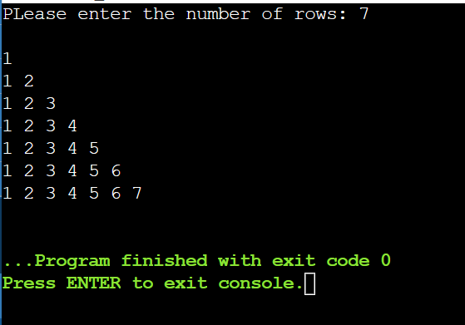

**TASK # 2**

CODE:

#include <iostream>

using namespace std;

int main() {

int sum = 0;

for (int i = 2; i <= 50; i++) {

bool isPrime = true;

for (int j = 2; j < i; j++) {

if (i % j == 0) {

isPrime = false;

break;

}

}

if (isPrime) {

sum += i;

}

}

cout << "The sum of prime numbers from 1 to 50 is: " << sum << endl;

return 0;

}

RESULT: 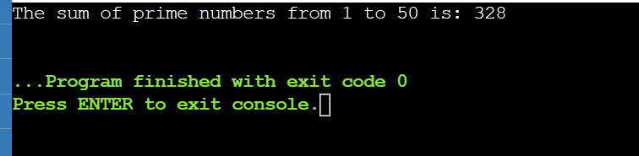

Task # 3

Code:

#include <iostream>

using namespace std;

int main(){

int row,n=1,x=0;

cout << "Enter the number of rows : ";

cin >> row;

for (int i = 0; i <= row; i++)

{

if (i == 0)

{

cout <<n;

}

for (int j = 1; j <= i; j++)

{

if (i % 2 == 0)

{

cout << i;

}

else

{

continue;

}

}

cout << endl;

}

return 0;

}

OUTPUT:

